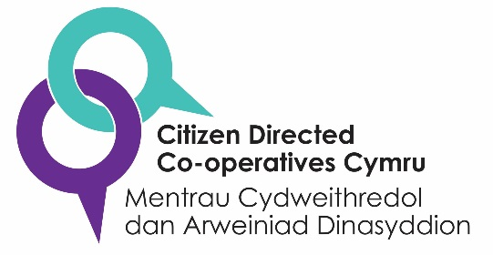
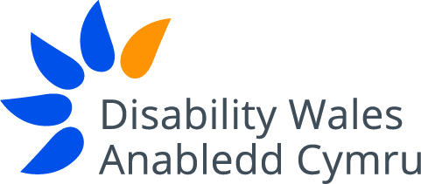
Save the Date

Direct Payments: Policy, Practice and Innovation
National Conference
Friday 20th July 2018, Media Resource Centre, Llandrindod Wells
10:30 – 16:00

This a FREE one-day conference, organised by Disability Wales:
- How direct payments can be used to support independent living for all ages
- Direct payments and the Social Services and Well-being (Wales) Act
- Support available to those receiving a direct payment
- Different ways of using direct payments
- Development of direct payment cooperatives
- Workshops
- Performances by UCAN, a creative arts cooperative and more!

Speakers include: Luke Clements the Cerebra Professor of Law and Social Justice at Leeds University. Look out for further details of speakers and the full programme to be confirmed

The conference is aimed at: Local authority staff working in social care and direct payments and commissioning; disabled people, disabled people’s organisations; parents and Carers; Welsh Government; direct payment support providers; academic bodies…..

A light lunch and refreshments will be made available and reasonable transport costs met for disabled people, parents and carers attending*
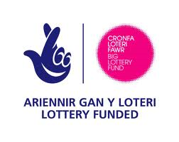
Register your place now through Eventbrite or telephone/email 029 20887325 info@disabilitywales.org

